Yanga Tsele

The Innovation Hub  : CoachLab (SITA)

Socio Economic issues in SA (Teenage Pregnancy)

Contents

Introduction 2

Problem Statement 2

Proposed IT Solution 2

How will the solution Benefit the society? 3

Stakeholders: 3

Limitations or challenges of the system 4

Infrastructure and Technologies 4

Cost Estimate 4

Conclusion 5

Reference 5

# Introduction

Socioeconomics also known as social economics is the social science that studies how economic activity affects and is shaped by social processes. In general, it analyses how societies progress, stagnate, or regress because of their local or regional economy, or the global economy. Teenage pregnancy and child bearing has often been rooted in the assumption that having a child is the key factor leading teen mothers into the life of socio- economic disadvantage, of it contributes to the rise of number of dropout rate with the education sector, poverty, hike in unemployment etc.

In this study we discuss the issue of teenage pregnancy and why it is an economic issue and propose a solution that will help reduce this matter using IT solutions and technologies.

# Problem Statement

Teenage pregnancy poses a challenge to our society and such pregnancies mostly are unplanned. This issue we tend to experience is mostly in rural areas and other under developed townships. According the city press article written *by Sipho Masondo, “Teen pregnancies hit 99000 a year” stated that more than 99 000 schoolgirls fell pregnant in 2013 at the rate of about 271 everyday of the same year.* This show that this issue affects mostly school girls between the age 16 – 19 and constitute to one of the reason the girls to drop out of school which contribute to the rates of dropout.

The causes of teenage pregnancy include a lack of access to sexual and reproductive health education and services. The expectations of communities on girls to become mothers early can be a cause along with sexual violence.one of the most concern is the phenomenal of “blesser”.

# Proposed IT Solution

A mobile application that consolidate parents, teenagers between the age 15 years downwards, awareness programmes and give access to information both to parents and teenagers. With this mobile application it will enable awareness programmes to share information to youth and parents, also it will help parents and teens to identify the nearest sex education centres and any other event that are related to sex education and teenage pregnancy within the areas that lack such resources.

It will also have a platform that will allow parents to communicate with teens and give advices about such issues and guide them to make better decision to teens that are already pregnant, this will break the barrier between the parents and their children about sex talk as parents will get more insight on how they can communicate with their children about such topics especially single parents that are raising the opposite gender children.

Popular awareness programmes such as Lovelife, Advocate for youth, Teenage Tatas will play a major role as they will be providing all the information that is relevant and also conduct sex education workshops and provide counselling without having to physically meet face to face around the communities and public schools.

# How will the solution Benefit the society?

With regards to the benefit of the society community members will get access to more information about teenage pregnancy and sex education for their youth. Secondly this will break the barrier between the parents and their children about sex talk as parents will get more insight on how they can communicate with their children about such topics especially single parents that are raising the opposite gender children. Number of teenage pregnancy will be reduced as teens, parents and community members will have broad knowledge about such issue of teenage pregnancy.

Other strategies that will help to reduce the teenage pregnancy is by doing school camps during holidays, do workshops at the surrounding schools and even in around the community, also engage more extramural activities

The engagement through this platform will measure how long do participant stays on the platform and also depend on how many comments or feedback received for a post related topic

# Stakeholders:

**Parents -** improve an open communication between them and the teens also provide guidance on sexual and productive health

**Teens** – attend workshops, participate in engaging topics and get access to sexual and productive health education.

**School teachers** - provide guidance to teens at schools and facilitate school camps.

**Community members** – attend and give input during sexual production health workshops

**Health practitioners –** provide training to teens about how to use contraceptives for safety purposes.

**Awareness programmes -** Run workshops and organise other activities such as school camps, gaming activities. Also facilitates engaging topics to educate teens about sexual and productive health

# Limitations or challenges of the system

1. System will benefit people who has access to smartphones
2. It will cater for people between the age of 15 – 45 years
3. Cannot change the language that’s suitable for one’s desire
4. Lack of training for older parents/ guardians

# Infrastructure and Technologies

1. Laptop or desktop computer for development
2. Mobile device for testing purposes
3. Angular js or Ionic framework software
4. Web servers
5. Database
6. Internet connection

**3G Technology** will be used to interconnect the devices and internet connection since the proposed solution will be operated on mobile devices.

**Cloud: Platform as a Service** The solution will be cloud based, therefore we will need platforms such as cloud servers and databases to host and operate the solution on the cloud.

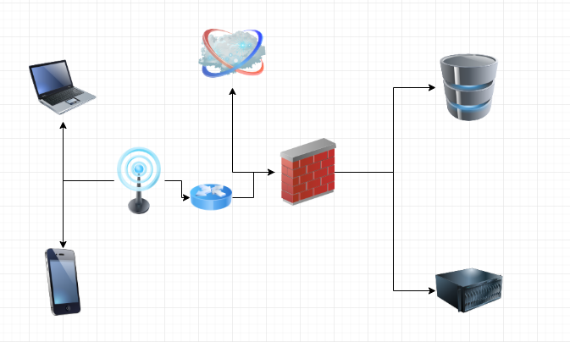

# Cost Estimate

|  |  |
| --- | --- |
| **ITEMS** | **ESTIMATED BUDGET** |
| **Operational Costs** |  |
| **Web-based Research and journals** | **R1 500** |
| **Laptop or Desktop Computer** | **R20 000** |
| **Software’s (development frameworks)** | **R10 000** |
| **Testing devices(mobile)** | **R10 000** |
| **Internet and Cloud Services** | **R17 000** |
| **Sub-Total** | **R58 500** |
| **Development Costs** |  |
| **Developer** | **R75 000** |
| **Maintenance** | **R50 000 pa** |
| **Sub-Total** | **R125 500** |
| **Overall Budget** | **R184 000** |

# Conclusion

Teenage pregnancy poses a challenge to our society and such pregnancies mostly are unplanned, however this issue of teenage pregnancy can be reduced as teens, parents and community members will have broad knowledge about such issue of teenage pregnancy. Participating awareness programmes will have more positive impact as they will be conducting workshops, counselling and other relevant programmes.

# Reference

1. <https://www.brandsouthafrica.com/governance/youth-and-education/the-fight-to-stop-teenage-pregnancy>
2. <http://www.advocatesforyouth.org/publications/publications-a-z/514-components-of-promising-teen-pregnancy-prevention-programs>
3. <https://www.news24.com/SouthAfrica/News/Teen-pregnancies-hit-99-000-a-year-20150905>